**Data Visualization in Excel**

**Data Visualization**is the representation of data in a graphical format. It makes the data easier to understand. Data Visualization can be done using tools like Tableau, Google charts, DataWrapper, and many more. Excel is a spreadsheet that is used for data organization and data visualization as well. In this article, let’s understand Data Visualization in Excel.

Excel provides various types of charts like Column charts, Bar charts, Pie charts, Linecharts, Area charts, Scatter charts, Surface charts, and much more.

**Steps for visualizing data in Excel:**

* Open the Excel Spreadsheet and enter the data or select the data you want to visualize.
* Click on the Insert tab and select the chart from the list of charts available or the shortcut key for creating chart is by simply selecting a cell in the Excel data and press the **F11 function key**.
* A chart with the data entered in the excel sheet is obtained.
* You can design and style your chart with different types of styles and colors by selecting the design tab.
* In Excel 2010, the design tab option is visible by clicking on the chart.

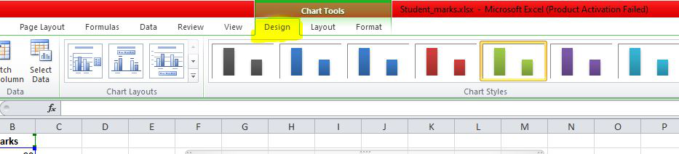

**Example 1:**

The Excel data is as follows:

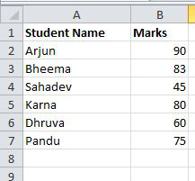

The column chart obtained for the data by following the above steps:

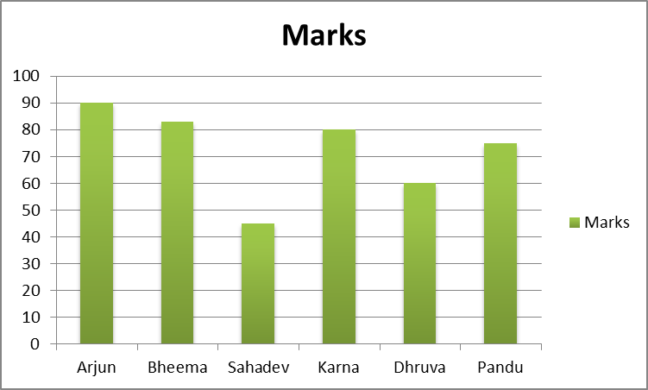

**Example 2:**

When excel data contains multiple columns and if you want to make a chart for only a few columns, then select the columns required for making the chart and press the **‘F11’ function key** or click on the Insert tab and select the chart from the list of charts available.

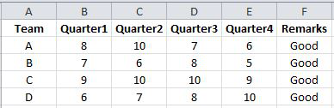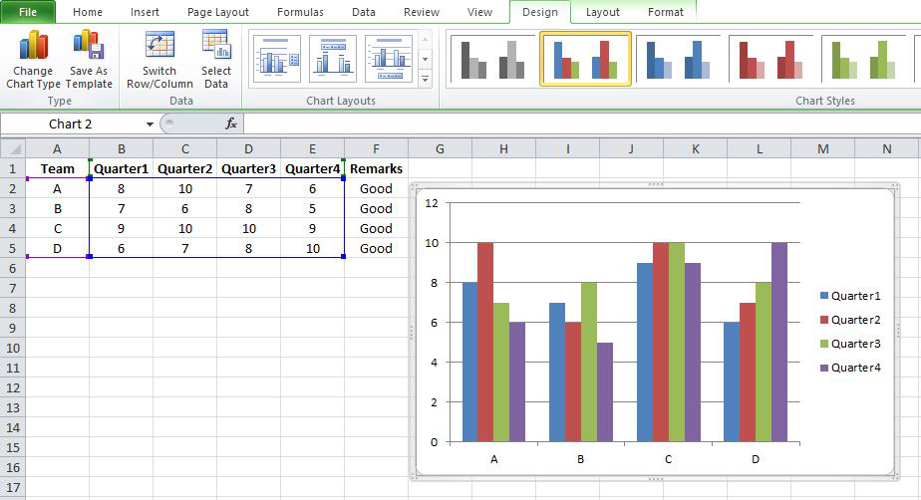

We can also select the required data columns by doing right-click on the chart and click on the ‘**select data**‘ option. Now, data can be added or removed for making the chart.

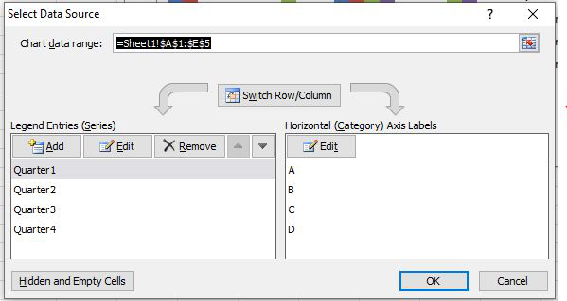

For swapping rows and columns in the chart, use the ‘S**witch Row/Column**‘ option available in the design tab.

We can also make different types of charts for the same spreadsheet data by clicking on the ‘**Change Chart Type’** option in the**Design tab**.

To make your chart more clear, use the ‘Layout’ tab. In this tab, you can more changes to your chart like editing the chart title, adding labels to your chart, adding a legend, and adding horizontal or vertical grid lines.

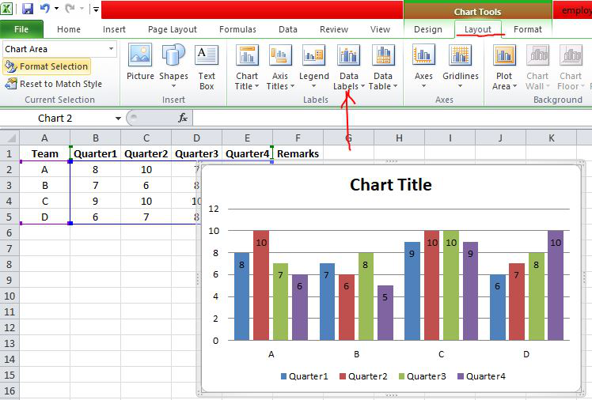

**Example 3: Formatting Chart Area**

To format the chart area, right-click on the chart and select the option ‘**Format chart Area**‘.

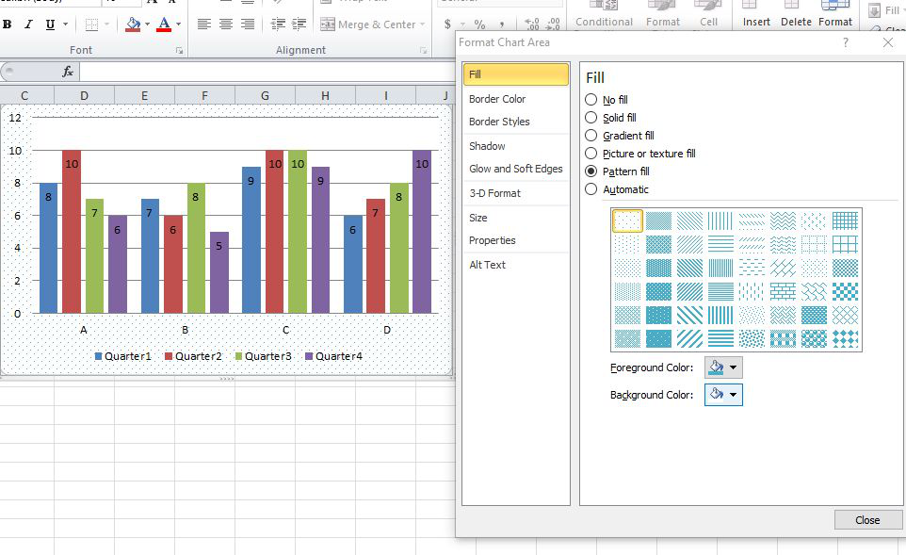

The format chart area provides various options for formatting the chart like Filling the chart with patterns and solid colors, Border colors, Styles for borders, the shadow effect for your chart, and many more. Formatting makes the chart look more attractive and colorful.

**Example 4: Creating Sparklines**

Sparklines in Excel are small charts that fit in the data cells of the excel sheets.

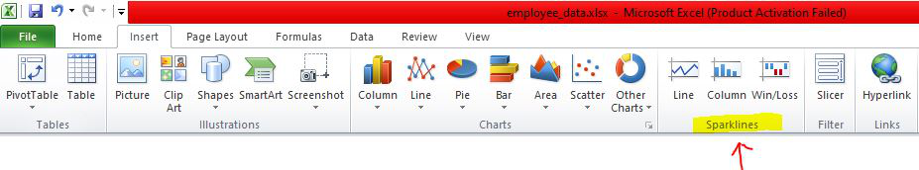

**Steps for Creating Spark Lines:**

* Select the Excel data range for sparklines as shown in the below figure.
* Click on Sparklines in the Insert tab and select any one of the three sparklines.

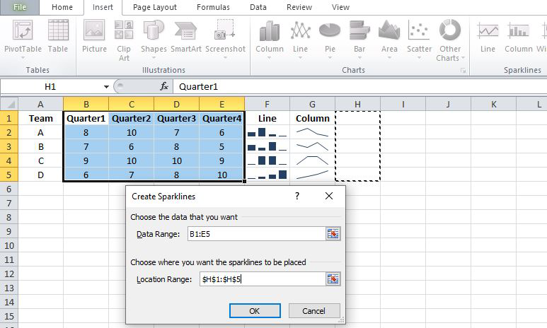

* Add the Location Range and Data Range for the creation of sparklines and click **ok.**

Finally, the F, G, H columns are displayed with the line, column, and Win/loss sparklines.

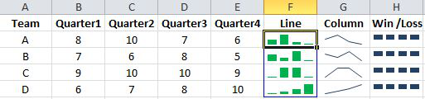

We can also color these sparklines by the Design tab as shown below:

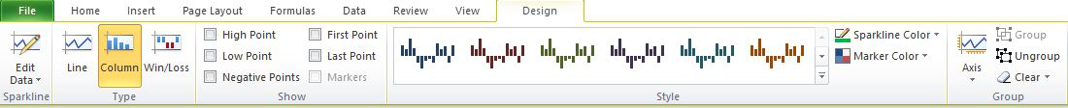

 We can Mark data points and also change Sparkline Color.

